**Recommendations for Improved Close Rate for Sales Process**

Hello SalesLoft Team,

Below is my analysis on the last 12 month denormalized dataset on your Bookings CSV file & my recommendations to follow to improve the Close Rate for your Sales process.

1. **Bookings Timeline Analysis:** Looking through the data set, I noticed that there was only one booking date in 2024 since 9/30/2020 which I have represented in a Monthly Bookings over Time Graph. The data show that this could potentially be a huge decrease in bookings frequency & potential data anomaly. 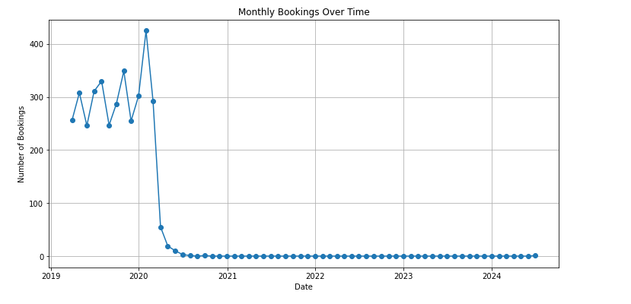

**Recommendations:**

* Conduct a thorough investigation into the missing booking dates after 9/30/2020 to find the root cause and verify the current data collection processes. Improve data collection processes to capture booking data accurately and consistently in the future. This could be done by implementing more routine data quality checks.
* Evaluate changes in booking processes, sales strategies, or market conditions that may have contributed to the decrease in booking frequency. Engage with the sales team to understand any challenges or obstacles faced during this period. (i.e Covid).

1. **Missing Values Analysis:** Checked for missing values using a “Missing Data Heatmap” and calculated the missing % for the “Lead Source”, “Global Region” & “Source” column. Missing values were filled with the value “Unknown” for better data validity.

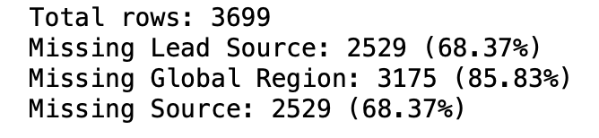

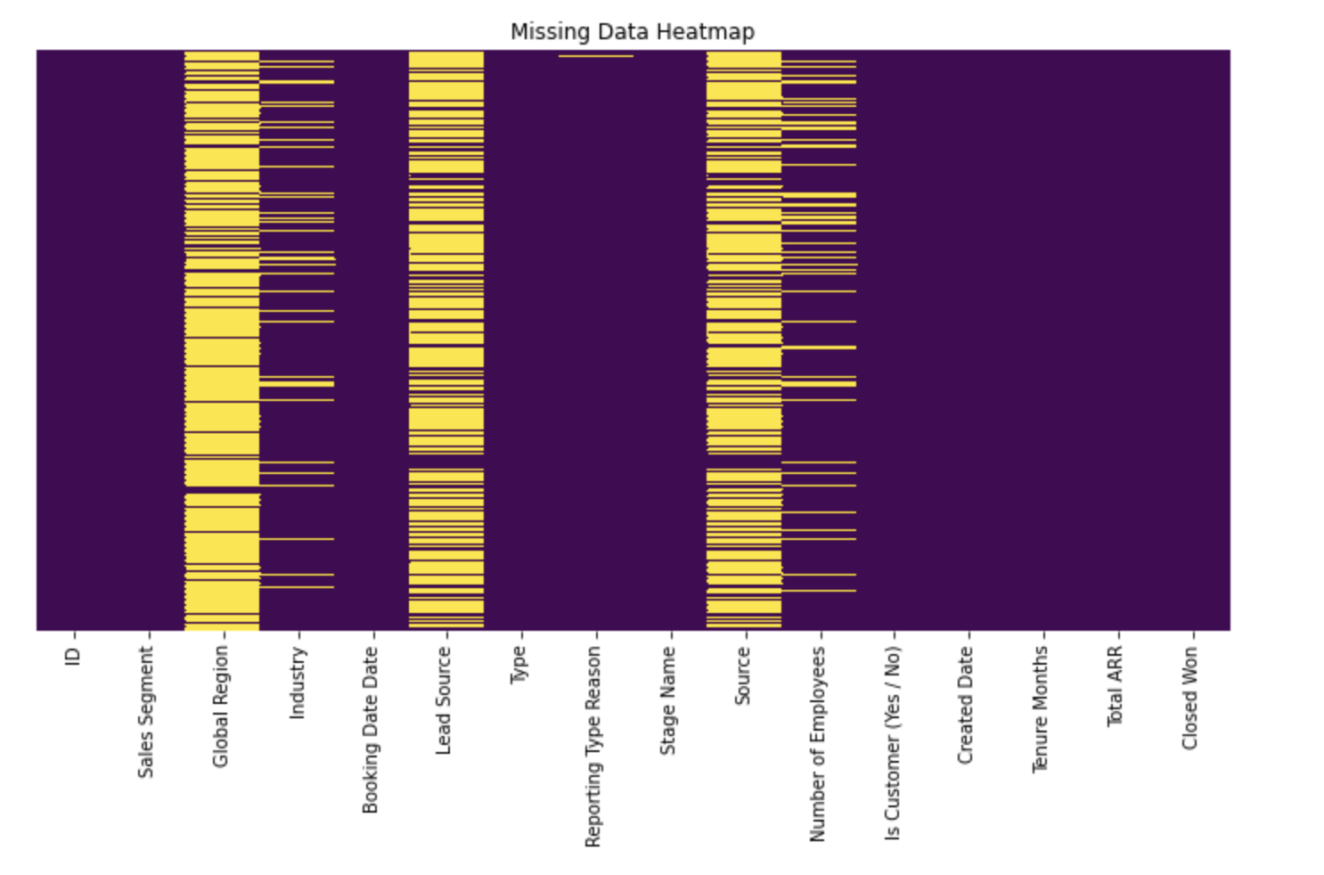

**Recommendations:**

* Conduct a thorough investigation into the missing values for Global Region, Lead Source, and Source to find the root cause and improve data collection processes to capture booking data accurately and consistently in the future.

1. **Lead Source Analysis:** Analyzed the effectiveness of different lead sources for close rate. 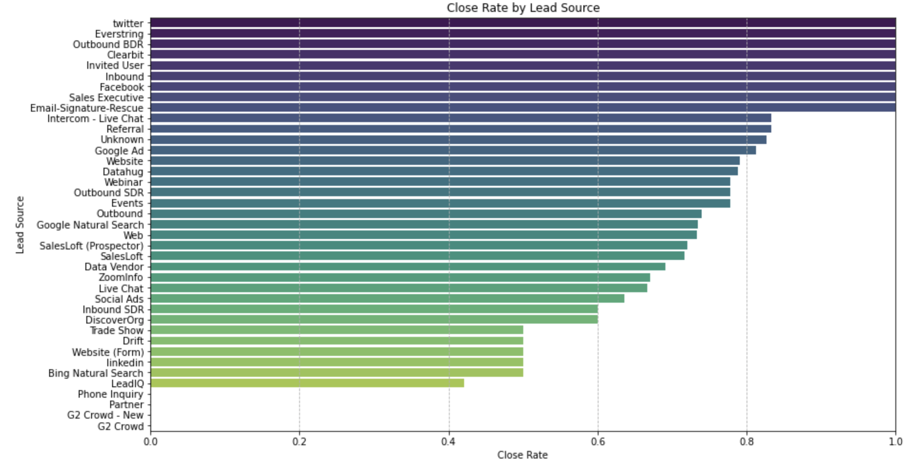

**Top Lead Sources:** Twitter, Everstring, Outbound BDR, Clearbit, Invited User, Inbound, Facebook, Sales Executive, Email Signature-Rescue

**Recommendations:**

* The visualizations show that certain lead sources have significantly higher close rates compared to others.
* Start by focusing on the top-performing lead sources and analyzing why they are successful. Apply these insights to other areas of the sales process.
* Leverage these top lead sources to attract, engage, and convert more leads which will improve the close rate and the sales process.
* Allocate more marketing and sales resources to these specific lead sources with higher close rates to aid in the sales process and conversion rate.

4. **Stage Name Analysis:** The bar chart displays the distribution of Deal Types across stages, showing the count and type of each stage.

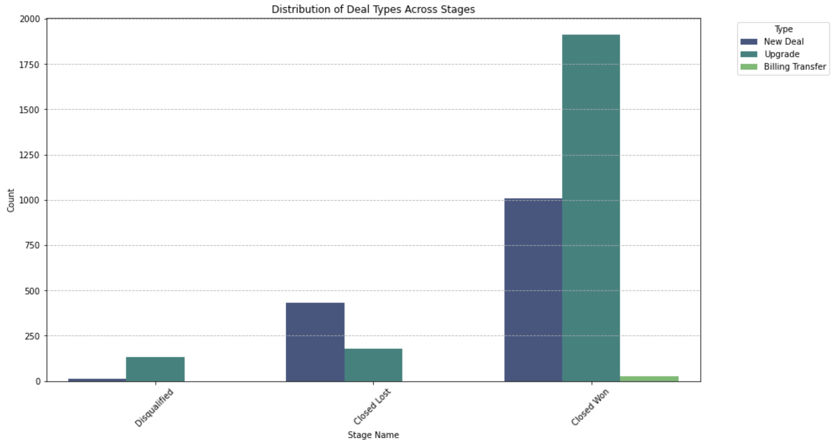

**Recommendations:**

* This visualization shows that Closed Won deals are predominantly “Upgrades” while Closed Lost Deals are predominantly “New Deals”.
* Focus on enhancing the upgrade process and leverage it as a strong selling point, especially at the time of renewal for customers deciding to churn or upgrade for a better deal.
* Focus on strengthening their approach for new deals through better qualification, training, and support.
* Map out the customer journey for both new deals and upgrades. Identify potential pain points and areas where prospects may drop off, and implement strategies to address these issues

5. **Sales Segment Analysis:** Bar chart displaying the Close Rate % based on Sales Segment.

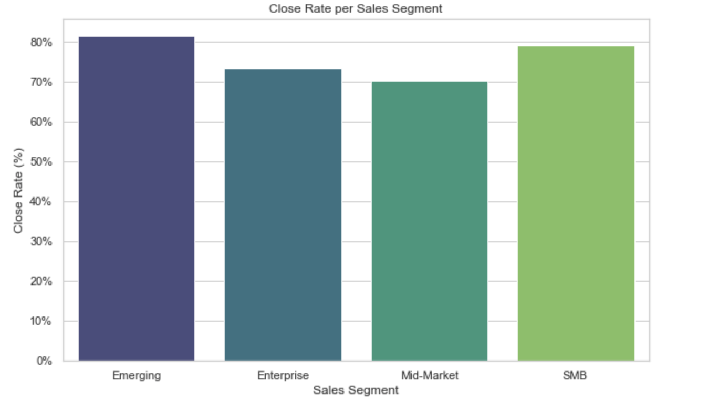

**Recommendations:**

* This visualization shows that the highest Close Rates are the “Emerging” & “SMB” Sales Segments.
* Engage with Emerging and SMB clients proactively to ensure they are satisfied and to identify any additional needs or opportunities for upselling and cross-selling.
* Focus on these segments by allocating more resources, simplifying the sales process, offering specialized training, and ensuring scalable and competitively priced product offerings.

6. **Global Region Analysis:** Bar chart displaying the Close Rate % based on Global Region.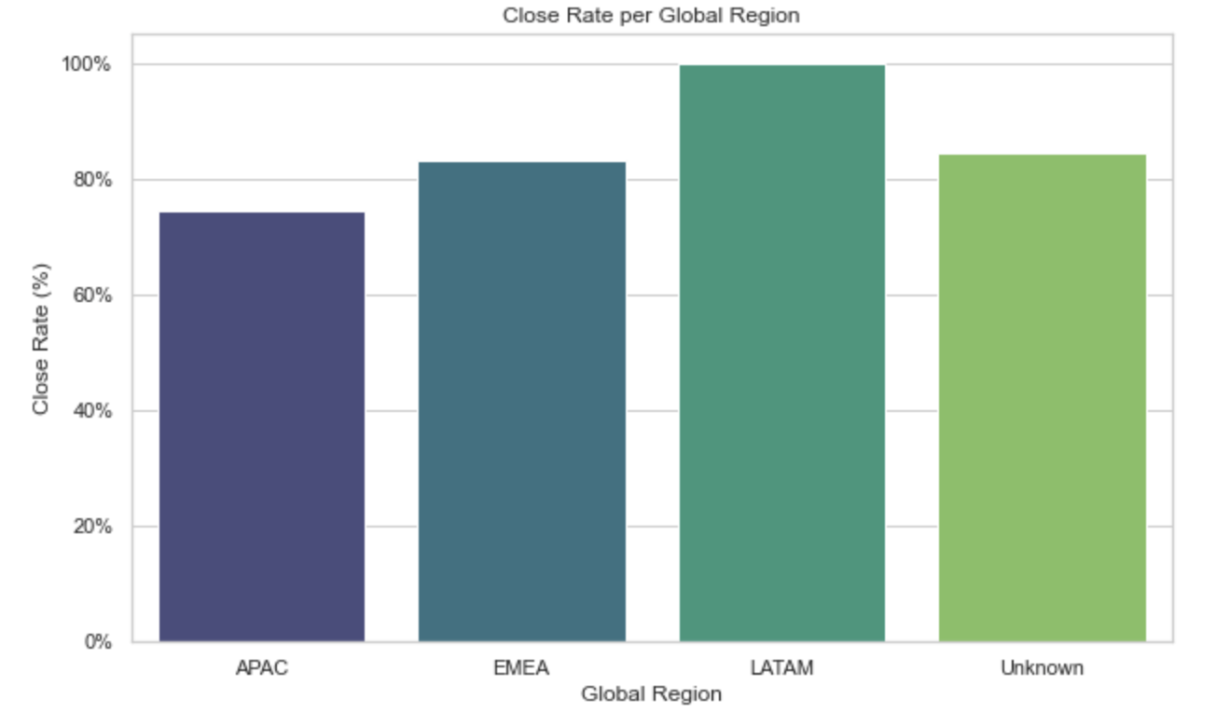

**Recommendations:**

* This visualization shows that the highest Close Rates are the “LATAM” & “Unknown” global regions.
* Keep up the momentum of highest close rate engaging proactively with LATAM clients to ensure their needs are met and they remain satisfied.
* Address the Unknown category by improving data collection and analysis. Investigate why deals are categorized under the Unknown region. Implement data validation processes to ensure regional information is accurately captured.

By directing attention to these areas, SalesLoft can refine its overall sales process, improve close rate, enhance customer satisfaction, and drive increased revenue. This can be achieved through implementing data validation processes to ensure data validity and closely monitoring performance across various stages, deal types, sales segments, and regions.